**Assignment -2**

Python Programming

|  |  |
| --- | --- |
| Student Name | ARTHY N |
| Student Roll Number | 621319104004 |
| Maximum Marks | 2 Marks |

**Question-1:**

Consider a list(list=[]). You can perform the following commands:

1. Insert i e: insert integer at position.
2. Print: print the list.
3. Remove e: delete the first occurrence of integer.
4. Append e: insert integer at the end of the list.
5. Sort: sort the list.
6. Pop: pop the last element from the list.
7. Reverse: reverse the list.

Initialize your list and read in the value of followed by lines of commands where each command will be of the types listed above. Iterate through each command in order and perform the corresponding operation on your list.

|  |
| --- |
| **Solutin:** |
|  | 1. colors=['green','blue','black']   colors.insert(2, ”orange”)   1. print(colors) 2. colors.remove(‘blue’) 3. colors.append(‘pink’) 4. n=[23,35,12,56,30]   n.sort()   1. n.pop(2) 2. n.reverse() |
|  |
|  |
|  |
|  |
|  |
|  |
|  |
|  |

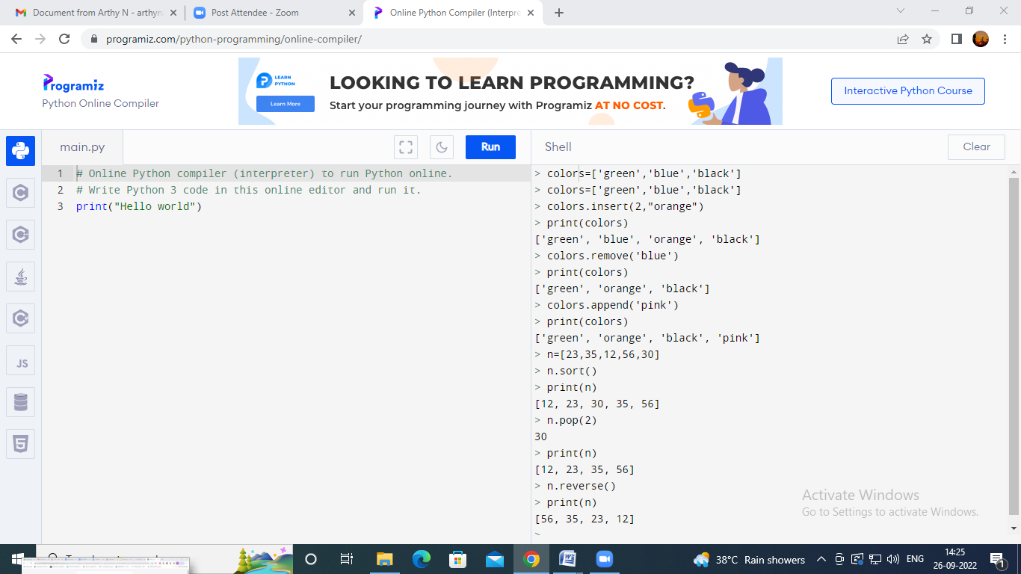

**Question-2:**

Write a calculator program in python?

|  |
| --- |
| **Solution:** |
|  | def add(x, y):  return x + y  def subtract(x, y):  return x – y  def multiply(x, y):  return x * y  def divide(x, y):  return x / y  print("Select operation.")  print("1.Add")  print("2.Subtract")  print("3.Multiply")  print("4.Divide")  while True:  choice = input("Enter choice(1/2/3/4): ")  if choice in ('1', '2', '3', '4'):  num1 = float(input("Enter first number: "))  num2 = float(input("Enter second number: "))  if choice == '1':  print(num1, "+", num2, "=", add(num1, num2))  elif choice == '2':  print(num1, "-", num2, "=", subtract(num1, num2))  elif choice == '3':  print(num1, "*", num2, "=", multiply(num1, num2))  elif choice == '4':  print(num1, "/", num2, "=", divide(num1, num2))  next_calculation = input("Let's do next calculation? (yes/no): ")  if next_calculation == "no":  break  else:  print("Invalid Input") |
|  |
|  |
|  |
|  |
|  |
|  |
|  |

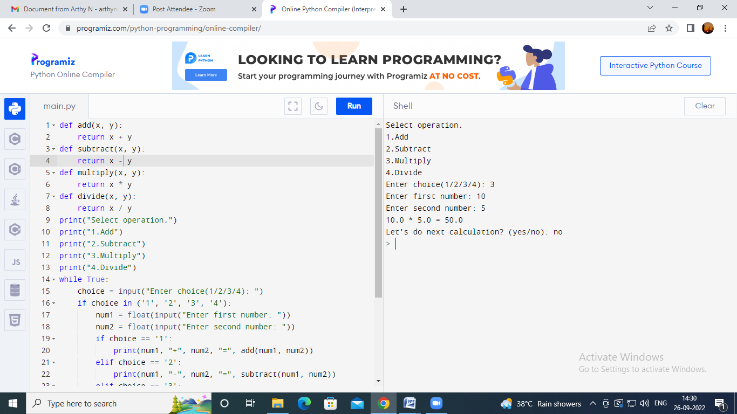

**Question-3:**

Write a program to concatenate, reverse and slice a string?

**Solution:**

str1="Hello"

str2="India"

print ("String 1:",str1)

print ("String 2:",str2)

str=str1+str2.

print(str)

def reverse(s):

    str = ""

    for i in s:

        str = i+str

    return str

s = "Hello IBM"

print(reverse(s))

String = 'Hello IBM'

print(String[:4])

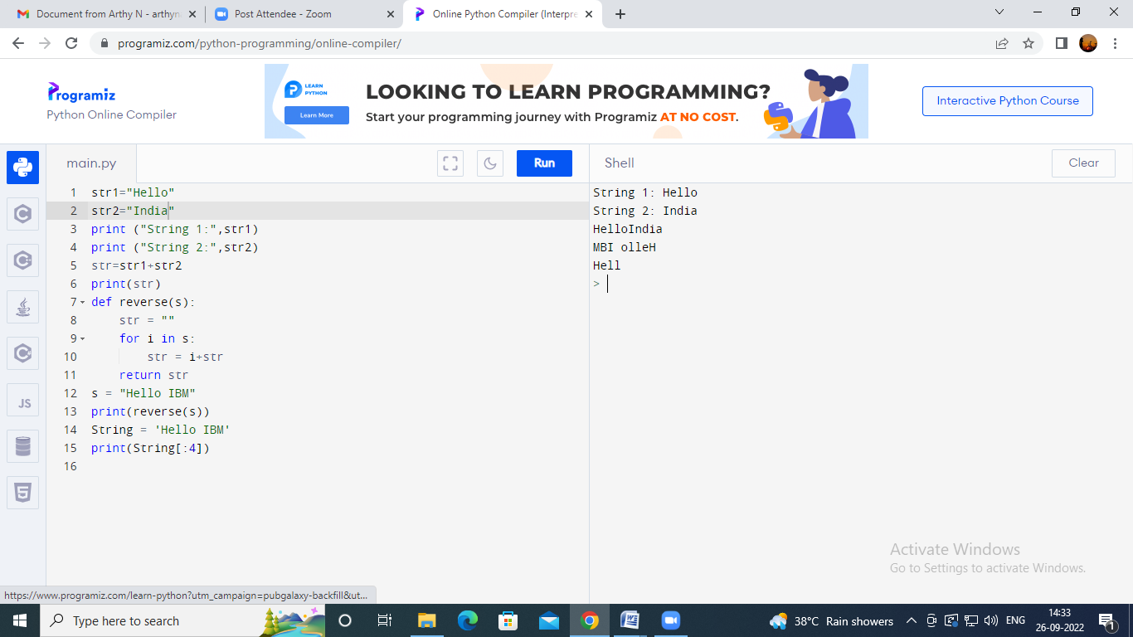

**Question-4:**

Why is python a popular programming language?

**Solution:**

Python was an easily understandable programming language. It has very simple syntax, which will be easier for the beginners to learn. And also it supports many libraries.

**Question-5:**

What are the other frameworks that can be used with python?

**Solution:**

* Django
* Flask
* Web2py
* Bottle

**Question-6:**

Full form of WSGI?

**Solution:**

Web server gateway interface